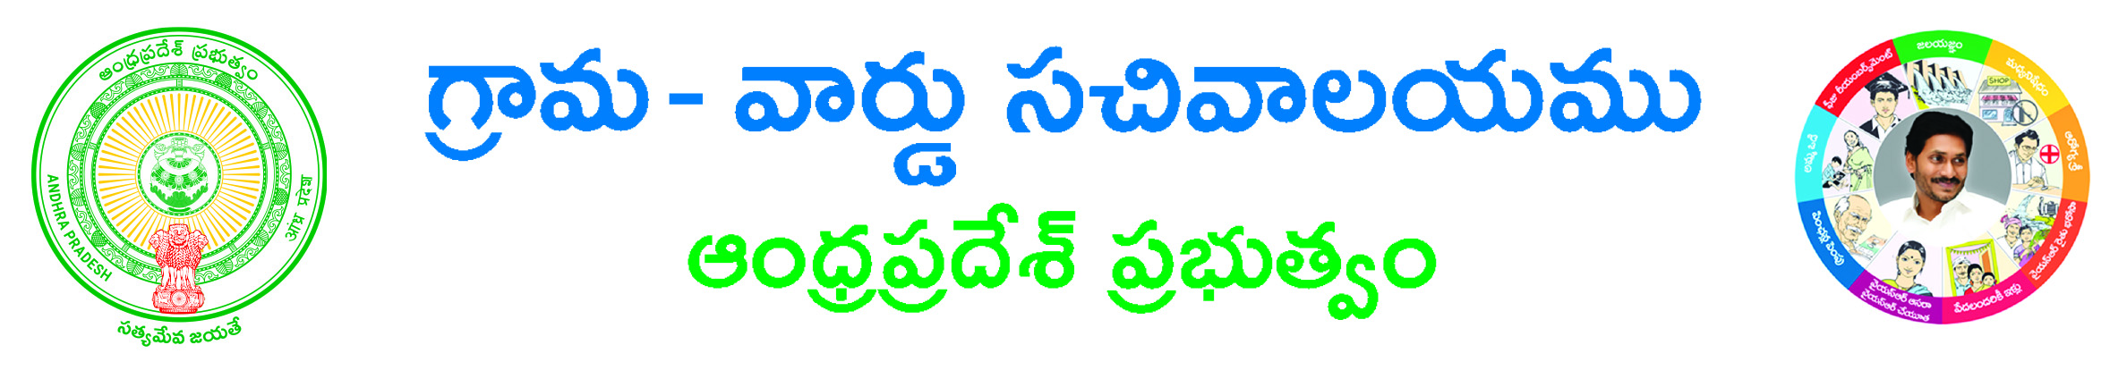
Late Registration of Birth Application Form

To
The Revenue Divisional Officer,
___________________ Division,
___________________ District.

Respected Sir,

Sub: - Request for Issue of the Birth Certificate of my son/daughter-regarding.

I, ______________________S/O / D/O / F/O / M/O / W/O________________________,
Age ____ years, occupation: _________, R/o H.No. ______, Near______________, ____________ Mandal, ________________Dist. Andhra Pradesh submit the following few lines for your kind perusal and sympathetic favorable consideration please.

That my wife’s name is ___________________ Age ________ years and my son/daughter ___________________was born on__________ (dd/mm/yyyy) in _______ Delivery at H.No.________, Near________, ___________ Mandal/Municipality, _____________ Dist. Andhra Pradesh. The information regarding birth of my son/daughter was not informed to the local Births and Deaths Registration Authority of ____________Mandal/Municipality. Hence the name of my son /daughter is not recorded in the Birth & Death Register of ______________________ Mandal/Municipality.

That my son/daughter requires birth certificate for further education urgently.

I enclosed here with Non availability certificate issued by the GP or Municipal Commissioner, Ration card copy, SSC marks memo and Self Affidavit.

Therefore I request you kindly to issue necessary orders to Commissioner, Municipal Council__________ to record date of birth of my son/daughter and issue Birth Certificate as above at the earliest.

Contact Details:
Landline Number: Yours faithfully,
Mobile No:
E-Mail ID:
Signature of the Applicant

Procedure: (following to be enclosed)

1) Physical Document*
2) Non availability certificate issued by the GP or Municipal Commissioner#
3) Ration card copy#
4) SSC marks memo#
5) Self Affidavit#

*-mandatory # -any one of them

